CS 255 System Design Document

UML Diagrams

UML Use Case Diagram
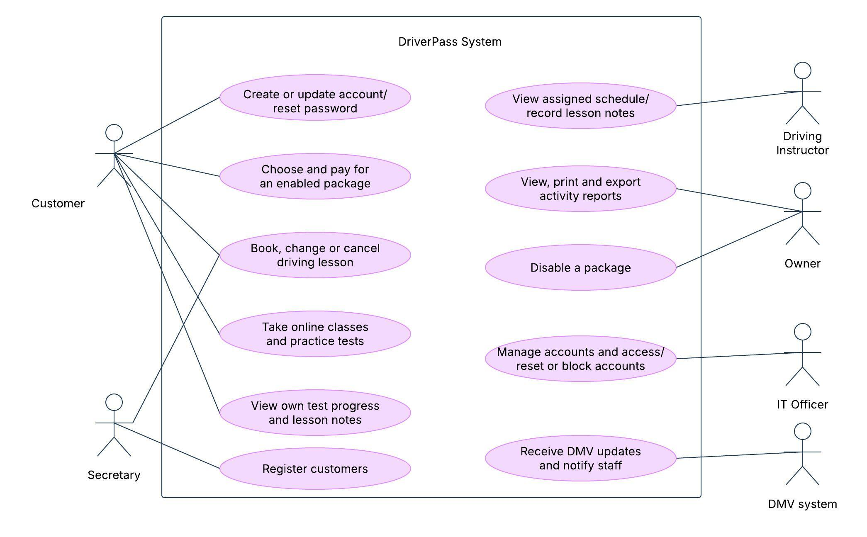

UML Activity Diagrams
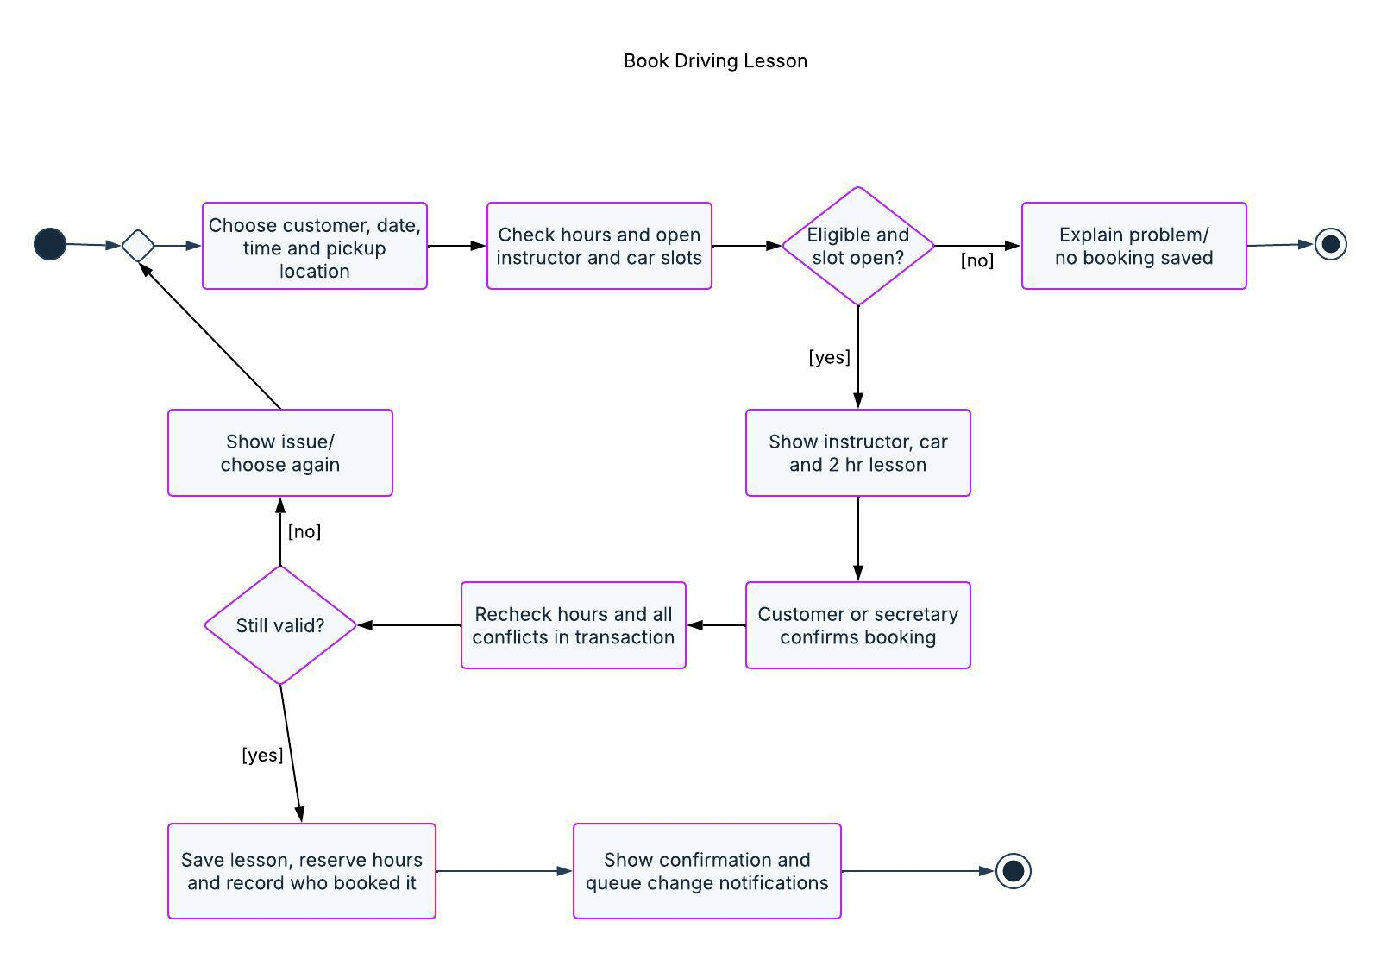
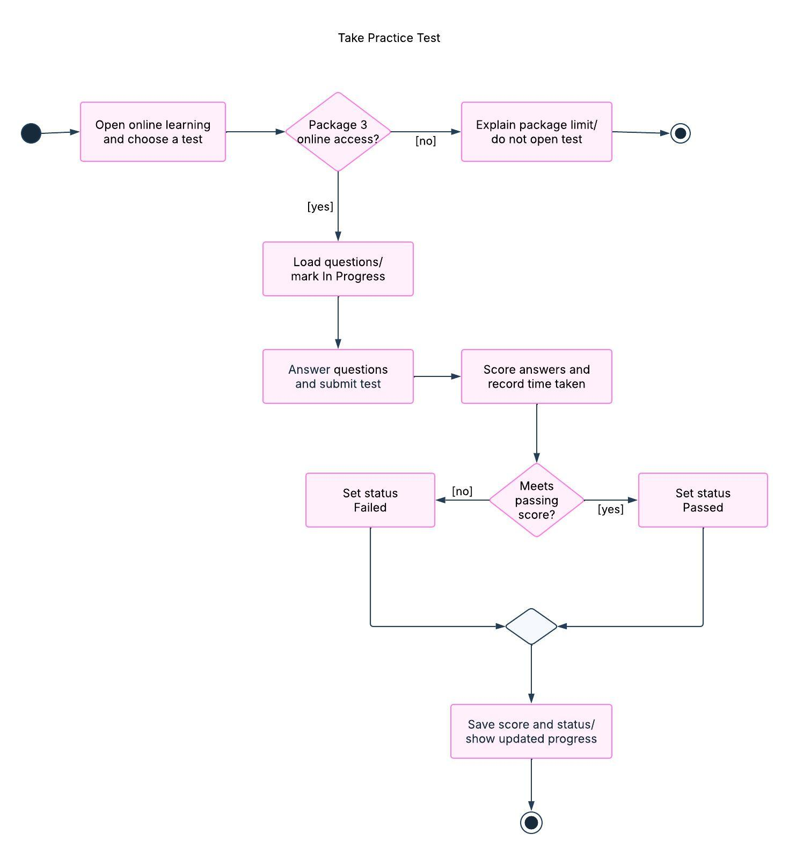

UML Sequence Diagram
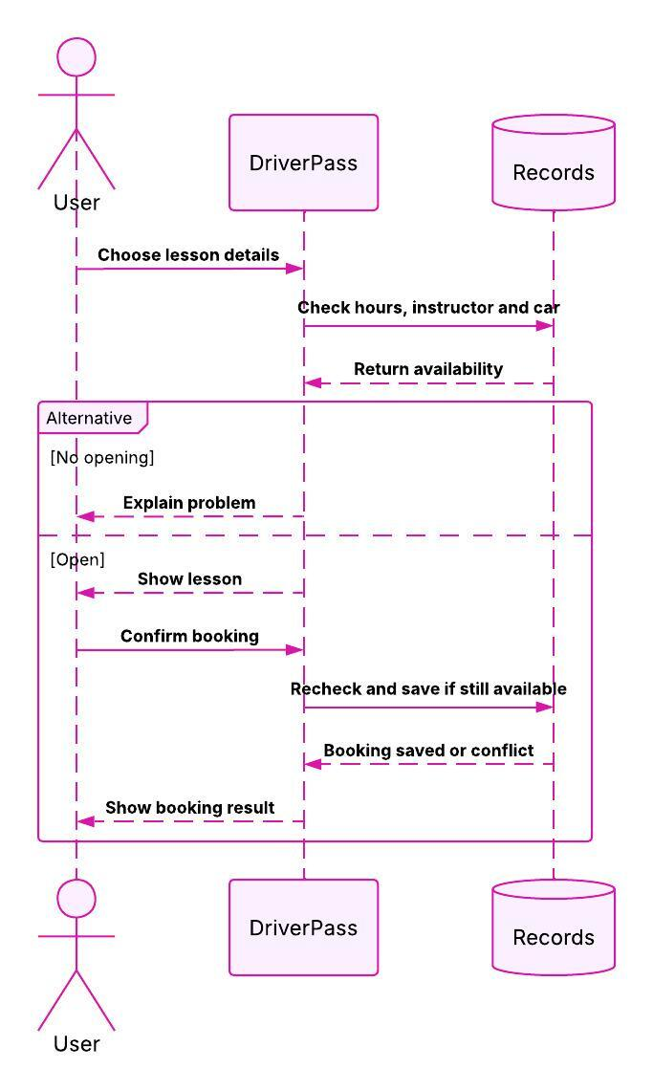

UML Class Diagram
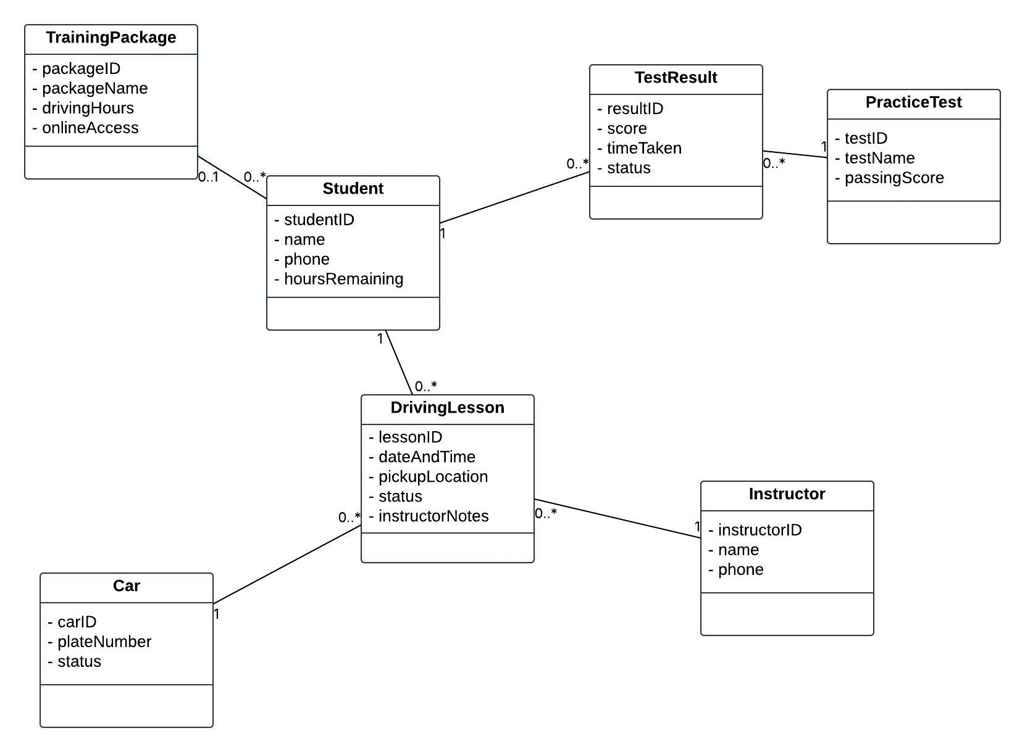

Technical Requirements
DriverPass would need some sort of hosting. I would definitely recommend that they use cloud hosting so they don’t have to deal with the headache of maintaining their own servers (last thing they need is more things to break along with their 10 driving cars). Its also good to note that DriverPass has not said how many people would be using the system all at the same time and how fast they would like the system to be. These requirements need to be discussed with the them before release of the system and have it tested.

Some general technical requirements for DriverPass should include some sort of computer/tablet/smartphone with a browser and internet connection for customers/staff. Office staff would also need a printer for printing out schedules/reports. These are the suggested functional requirements for the system. There are a couple of items here that still need further clarification with the owner before any building of the system takes place. Customers need registration to create a customer account and the ability to view lessons/packages they have registered for (ex. Package 1 consists of 6 hours of driving lessons, Package 2 consists of 8 hours of driving lessons and 1 in person traffic rules lesson, and Package 3 consists of 12 hours of driving lessons, 1 in person traffic rules lesson, and online DriverPass traffic rules lessons and exam). Customers also need the ability to reserve available driving lessons, take DriverPass online traffic rules lessons and exam with Package 3, and view their driving lesson progress.

Staff/instructors need the ability to register a customer, add/modify/delete appointments, view their schedule, and add lesson notes. The owner/admin needs the ability to turn packages on/off (ex. Package 3 is not available for registration) and view reports. Reports will be able to be printed/downloaded to a Microsoft Excel type of program. These reports will not be in real time data if they are downloaded.

Some nonfunctional requirements for the system include a website that will need to be mobile and desktop friendly. For DMV updates, need to figure out if DriverPass will be receiving these updates electronically or if an employee will be logging into the system to update these records. If electronically, need to figure out a way for these records to be entered electronically. If not electronically, then will need to discuss who from DriverPass will be allowed this access.

User authentication/authorization will also be needed. User passwords will not be stored in plain text. There will also be a need for some sort of account recovery process for forgotten passwords. Users will only be able to access/view their own information. Instructors will only be able to view their schedules/appointments. There will also be different roles/access levels for DriverPass employees (ex. owner/admin will be able to access more reports than front office staff, IT will be able to access user administration).

Payments will be processed through a thirdparty payment processor. Only payment transaction data and references to this data will be stored in the DriverPass system. No credit card data will be stored in the DriverPass system. Appointments/changes to appointments will need to be monitored (like who made the change and when did they make it).

Customer/instructor information entered by the front office staff will need to be normalized (properly related). Appointment records will need to be related to the proper customer, instructor, and vehicle records. Validation will take place when a customer/staff member tries to reserve a driving lesson to make sure the customer, instructor, and vehicle are available. Validation will also take place to make sure the customer still has driving lesson hours left. Validation will also need to take place upon submission in case multiple users are trying to make the same appointment at the same time.

Driving lessons will consist of 2 hours. My suggestion (needs confirmation from the owner) is that these 2 hours would be deducted from the customers lesson package when an appointment is made and will be added back when an appointment is canceled. If an appointment is changed to an unavailable time, the original appointment will stay booked. Customer/instructor/admin (as needed) will receive notification of changes to an appointment. Pickup/dropoff location will be the same.
The hosting company will be responsible for the availability of the system as well as performing backups and applying updates. DriverPass IT (whoever that may be) will want to make sure the hosting vendor is actually performing system backups and that these backups can be properly recovered (nothing worse than finding out your backups don’t work when you need them). DriverPass IT will also want to make sure any issues are addressed in a timely fashion.

There will most likely be a need to send emails (password reset, appointment updates). Failed emails to notify appointments should not affect updating of appointment information. Suggesting to using Lucidchart for diagrams. There are an infinite number of text/code editors to choose from.
I would definitely suggest using a test environment separate from production (does not use live customer data). Some things that will need to be tested include users making appointments for the same vehicle, lesson reservations (making sure validation is working), online traffic rules lessons/exam (Package 3), user authentication/authorization, payments, reports, and backups/recoveries.

